Laboratory 3 – Week 3

Mathematical Foundation

### 3.1 Introduction

This document highlights some of the mathematical foundation required for this module and describes two mathematical tests for you to practice on. These tests are not part of the assessment for this module; however, you are encouraged to attempt them.

The tests are aimed to help you appraise the level of your own mathematics ability; after taking the test, it is your own responsibility to sign up to any appropriate training sessions run by ASK if you need to improve your skills.

### 3.2 Resources and Practice Tests

You are encouraged to use [Maths E.G.](http://www.mathcentre.ac.uk:8081/mathseg/) when you are practicing for your tests. It is an excellent resource with a large database of questions, each with thousands of examples and fully worked out solutions. However, note that this resource contains a very large number of mathematical concepts and many of them are not relevant to module.

### 3.3 The Maths Tests

There are two mathematics tests for you to attempt. The use of calculators, websites, pens and paper is encouraged. As long as you understand how to solve the problems in hand, it does not matter how you reach the answer!

The Algebra test can be accessed from the following URL:

<http://www.mathscentre.ac.uk:8081/mathsegteacher/mytest.jsp?tid=787&rt=3a1aecaf-0c76-4bac-9565-90bac7033d46>

The Statistics and Probability test can be accessed from the following URL:

<http://www.mathscentre.ac.uk:8081/mathsegteacher/mytest.jsp?tid=789&rt=7949367f-5a4b-497a-88ff-afe57ddd1f70>

The above links should take you to the following page, where you will need to enter your name, ID and email address to be able to access the test.

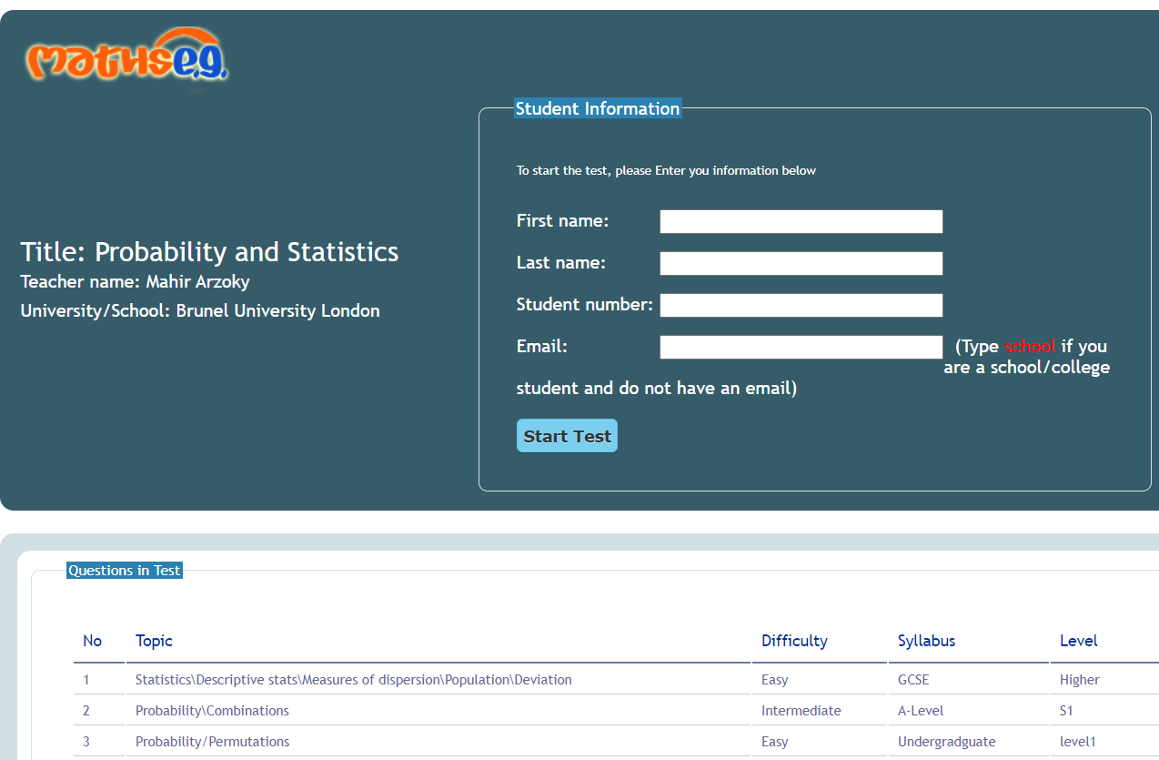

Once you start the test, you will need to answer each question to proceed to the next. After attempting each question, you will be provided with the answer for the question and in most cases an explanation of how the answer is worked out. There will be around 10 questions for each test.

Once you have answered all the questions make sure that you submit your test at the end. You may repeat the test as many times as you wish – it will be a different test with different questions. If you think that you still need more practice feel free to use the Maths E.G. website or other online resources.

### 3.4 More Tests

If you have completed the Maths tests and would like more to do, then you are in the right place! You may attempt the following two short tests; they are on basic algorithms and on counting the primitive operations of algorithms. Follow the same procedure as above.

**Basic Algorithms**

<http://www.mathscentre.ac.uk:8081/mathsegteacher/mytest.jsp?tid=794&rt=d346bbdd-6635-474c-84cd-1124a9a83e63>

**Primitive Operations Count**

http://www.mathscentre.ac.uk:8081/mathsegteacher/mytest.jsp?tid=792&rt=bcde8a2d-78c4-47e8-93eb-870999fdfe33